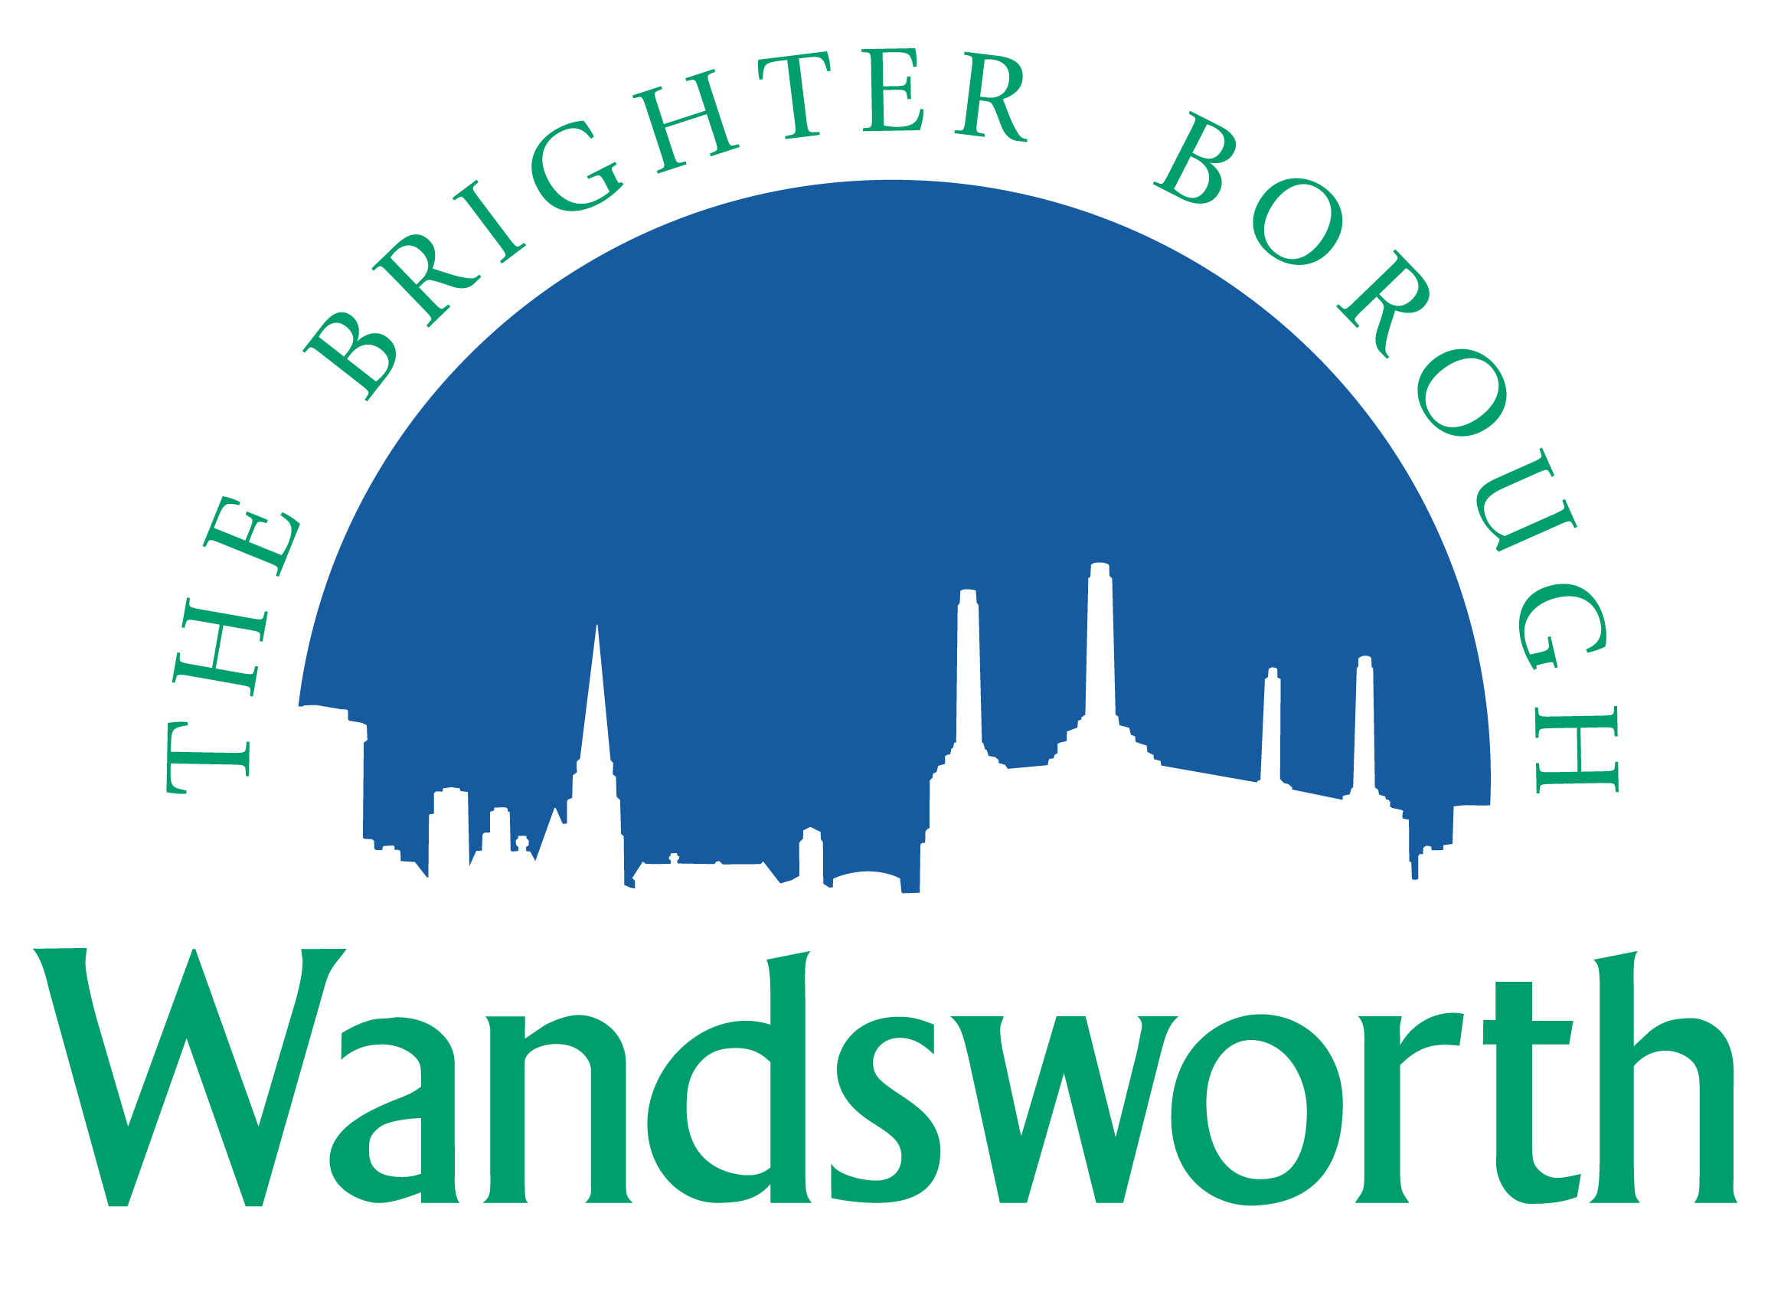
Wandsworth Borough Council

Planning Application Requirement Checklist

Notification of Proposed Works to Trees in a Conservation Area

Please indicate on the form below the information you are providing with your application including the document file names if you are providing the documents electronically. To ensure that your application is valid it is important that you provide all the information indicated in the Council’s Planning Application Requirements. These are available on the Council’s website at:

http://www.wandsworth.gov.uk/downloads/file/4933/planning_application_requirements

Please provide 2 copies of all relevant material if applying on paper.
The Council requests that all plans and drawings should indicate: drawing number; paper size (preferably A3); key dimensions; and a scale bar indicating a minimum of 0-10 metres.

Application Details
Applicant
Site Address
Date

Information requested | Provided – please tick/delete as appropriate | Document file name(s) – if supplying electronically
Completed application form | Yes No
Plan showing location of all tree(s) | Yes No
Specification of the works to be carried out | Yes No
Photographs/photomontages | Yes No
Report by a tree professional (arboriculturalist) | Yes No

